Table of Contents

1. **PandaDoc** **2**
2. **Aspose or GroupDocs** ……………………………………………………………………………….………2
3. **PDFTron**4
4. **Comparison Table**…………………………………………………………………………………………...5
5. **Question and Answer from Support of Aspose Forum**……..………………….....………….6
6. **Question and Answer from Support of PDFTron Forum**…………………….…………………….7

1. **PandaDoc:**

PandaDoc is a considerable option if you need a better PDF apparatus because it comes with technological features and continual upgrades. As a result, multiple users refer to it as an all- round automation tool.

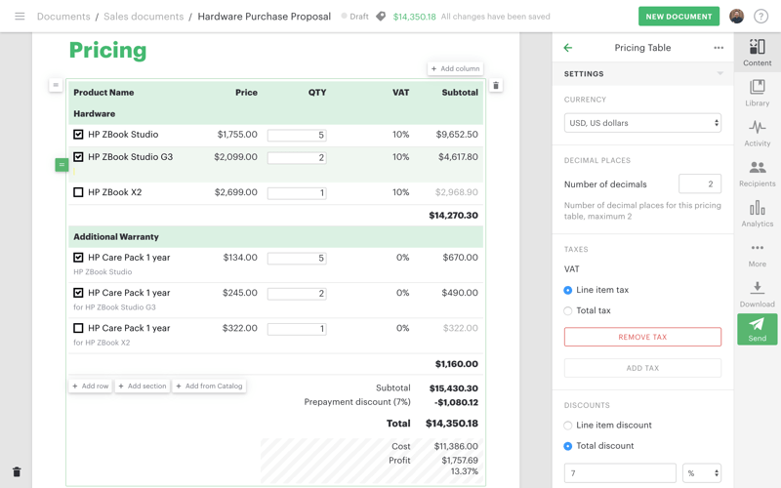

**Features**

Authenticates using unlimited electronic signature

Tracks task progress

Uses advanced document analytics

It provides reminders and expirations

mobile PDF SDK, it is mobile

**Pros**

It provides analytics reports that helps businesses increase their wins

It includes a calculator for tax calculations

**Cons**

Navigation t other fields is difficult

It does not possess the key features for

PDF manipulation.

[Free Download PandaDoc >>](https://www.pandadoc.com/)

1. **Aspose or GroupDocs**

GroupDocs creates easy to use, comprehensive online document management APIs for .NET, Java and Cloud, as well as a range of Cloud apps that improves document collaboration for organizations of any size.

Our goal is to make the lives of developers who work with document management systems easier by giving them tools that save them time and effort. Document management – whether it's gathering signatures, posting documents on websites or collaborating with others to improve a text – should be easy. This is our vision - Enable applications that allow people to work faster, together.

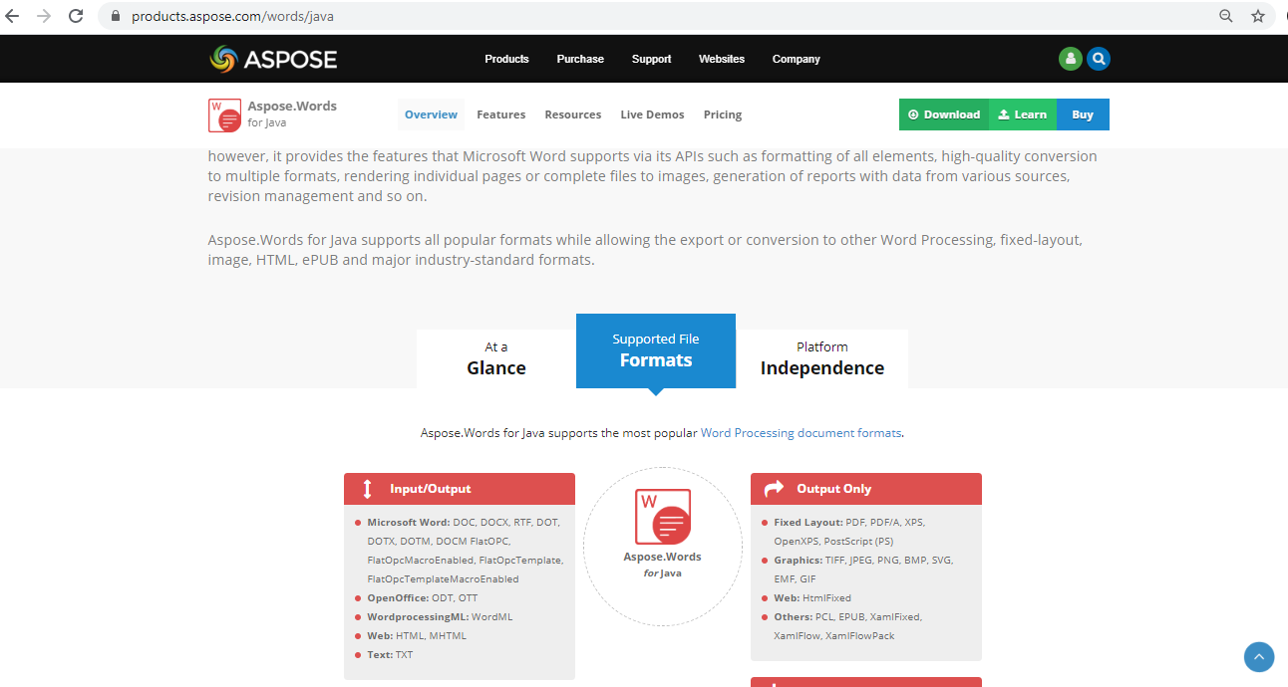

[Pricing:](https://purchase.groupdocs.cloud/pricing)

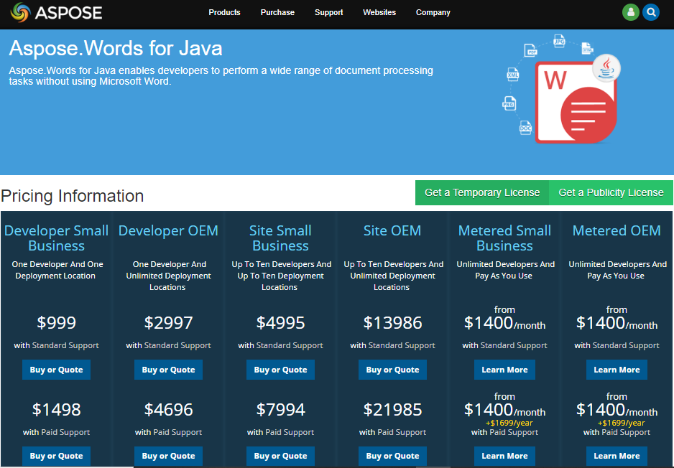

[Free Download](https://www.groupdocs.cloud/)

1. **PDFTron**

PDFTron is software with multiple basic and advanced features that facilitate the manipulation of PDFs. PDF SDK is well supported such that it does not need third-party software to function properly. It offers numerous PDFTron license options according to your business model and requirements. They include Enterprise and OEM redistributable licensing.

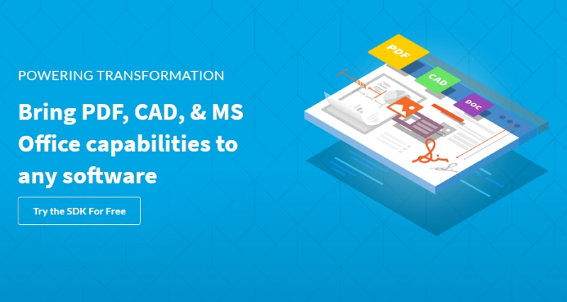

PDFTron pricing for licensing starts at $4000 annually. According to PDFTron Glassdoor, the PDFTron creators are pleased with their task and work environment.

The features include:

* Annotation and collaboration
* Format conversion
* Document security through redaction and password protection
* Data extraction
* PDF manipulation through editing
* Creation of optimized and compliant PDFs

Pricing : <https://www.pdftron.com/licensing/>

[Free Download](https://ssl-download.wondershare.com/pdfelement-pro_full5239.exe)

1. **Comparison Table:**

|  |  |  |
| --- | --- | --- |
| Queries\Companies | Aspose Or GroupDocs | PDFTron |
| File Comparisons | This tailored to our requirement and any format file can compared  Documentation Link:  <https://docs.aspose.com/display/wordsjava/Home> | Any format file will convert to pdf then compare, limitation pdf as input  Documentation Link: <https://www.pdftron.com/documentation/java/get-started/integration/windows/> |
|  | Live Demo [Word Comparison](https://products.aspose.app/words/comparison) | Live Demo : [PDF Comparison](https://www.pdftron.com/webviewer/demo/compare-files) |
| Annotations | For format file like Word, Excel, PowerPoint, Email and more | For format file like Word, Excel, PowerPoint, images and PDF |
|  | Live Demo : [Word](https://products.aspose.app/words/annotation), [Excel](https://products.aspose.app/cells/annotation) | Live Demo : <https://www.pdftron.com/webviewer/demo/> |
| CAD Files View | Live Demo:  [Aspose.CAD Viewer](https://products.aspose.app/cad/viewer)  [Aspose.CAD Conversion](https://products.aspose.app/cad/conversion) | Live Demo: <https://www.pdftron.com/webviewer/demo/cad-viewer> |
|  | GroupDocs or Aspose Total Java: <https://docs.aspose.com/display/totaljava/Home> | PDFTron  <https://www.pdftron.com/documentation/java/download/windows/> |
| Pricing | Pricing:  <https://purchase.groupdocs.cloud/pricing> | Pricing : <https://www.pdftron.com/licensing/> |
| Ratings(5 is Excellent) | Company: 5  Forum Support Response:4  Over All: 5 | Company: 5  Forum Support Response:4.3  Over All: 4 |
|  |  |  |

1. **Question and Answer from Support of Aspose Forum**

https://forum.aspose.com/letter_avatar_proxy/v4/letter/s/e274bd/40.png suhailahmed:

Q: Need some steps or article to do integrate with LIferay. It would be great help and I want to present a POC with this integration. And more over have many questions or our requirements as follows:

A: I am afraid; we do not currently have any such article in documentation that provides step by step instructions on how to integrate Aspose APIs with LIferay. But, we have logged your request and will keep you posted in this regard. (Ticket# **WORDSNET-20326**)

https://forum.aspose.com/letter_avatar_proxy/v4/letter/s/e274bd/40.png suhailahmed:

Q: What is the maximum file size will it support, in our work space we have file size approximately 30 to 50 MB and more than 3,000 pages in MS Excel and Word.

A: There is no limit on maximum size of document that Aspose APIs can generate or process. The only limit is the amount of RAM (memory) available on your side.

https://forum.aspose.com/letter_avatar_proxy/v4/letter/s/e274bd/40.png suhailahmed:

Q: 10 concurrent users Collaboration on same file possible?

A: I am afraid, concurrent users cannot modify the same Excel or Word Document (e.g. this is due to limitation of MS Excel file) however reading is allowed for concurrent users.

Also, please note that Aspose.Words API is multi-thread safe as long as only one thread works on a Document at a time. There is no limit on processing of number of documents at the same time. Aspose.Words supports multi-threading and processing multiple documents simultaneously in different threads should work fine. Aspose.Words also does not impose restrictions on number of threads.

https://forum.aspose.com/letter_avatar_proxy/v4/letter/s/e274bd/40.png suhailahmed:

Q: We have to keep in same server where liferay is running or we can also keep in separate server and communicate with API calls. as keeping in separate server recommended for prod?

A: We have options for both i.e. you can use DLL/JAR for using Aspose APIs from the same system and Cloud based solution where files are processed via REST APIs. Please check following links:

* <https://products.aspose.cloud/cells>
* <https://products.aspose.cloud/words>

https://forum.aspose.com/letter_avatar_proxy/v4/letter/s/e274bd/40.png suhailahmed:

Q: What are all the file types will support in future needs?

Please check the following pages:

* [File Formats Supported by Aspose.Cells](https://docs.aspose.com/display/cellsnet/Supported+File+Formats)
* [File Formats Supported by Aspose.Words](https://docs.aspose.com/display/wordsnet/Supported+Document+Formats)

**Aspose.Words for Java's main feature areas and how they relate to each other.**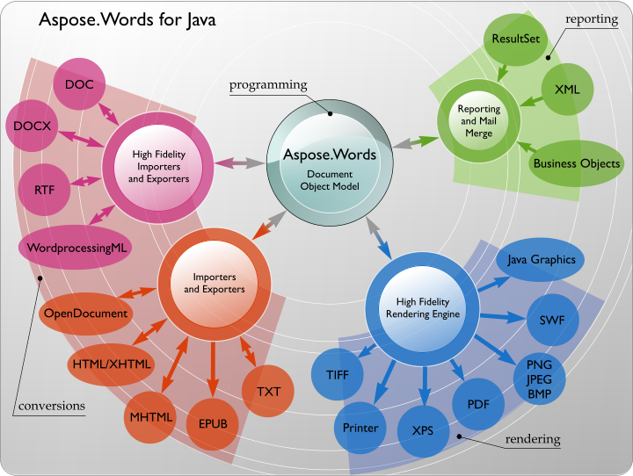

1. **Question and Answer from Support of PDFTron Forum**

Thanks for reaching out to us. We haven't yet developed integrations for Liferay, however looking over its Plugins SDK it seems like you can add your own custom JavaScript to a page.

Have you tried integrating WebViewer so far? It includes all the capabilities you list.

​

Note that WebViewer doesn't include CAD->PDF conversion inside JavaScript code, but that's something that can be provided through our native PDFTron SDK for Windows/Linux. Does LIferay include a serverside environment where you can run native code?

Check your ticket status - <https://support.pdftron.com/helpdesk/tickets/13442>